

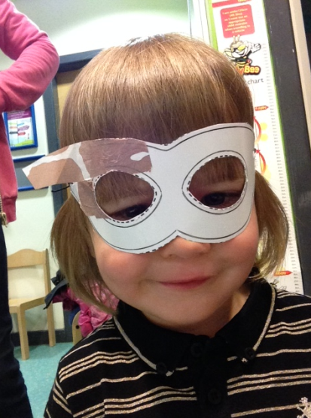

**New Courses Starting September**

**Thursday 18th September** – Family English

**Wednesday 17th September** – Safeguarding

Contact Unity 478129, to book your place.

£FREE Crèche available.

We have had a lot of BIG changes at Unity Children’s Centre over the last 6 months, and we would like to thank you for your patience. We appreciated your feedback and can update you on the following;

**Car park facilities**

We now have our car park back. (Gates are locked between 8.30am – 9am and 2.34pm-3.15pm for school drop off and pick ups.)

**Activity garden**

Lots of brand new resources including an outdoor den.

**Sensory room**

Inside the activity room is a new sensory room, for you to enjoy.

**National Bookstart Week**

We have recently celebrated ‘National Bookstart Week’ 09th – 15th June. Looking at who our favourite superhero’s are. Who is yours?

**We are open during the holidays, bring the whole family along**

**New Timetable**

The Summer Timetable is now available. If you would like to book on any of the trips, please contact the centre, or pop in to pay your deposit. Don’t miss out!!

**Information Drop In**

**Friday 27th June** – Blackpool Stop Smoking advice and support.

**Wednesday 16th July -** ‘Communicate’ Speech and Language drop in.

Welcome to Unity Academy Children’s Centre Summer Newsletter. We would like to wish you a lovely summer break, and look forward to seeing you at one of our activities or events this year.

Unity Academy

Children’s Centre Summer Newsletter

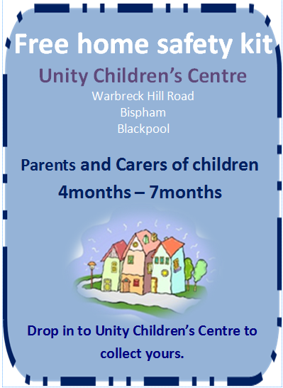

Cut out and bring with you

**Dental Helpline**

For advice on how to find a local NHS dentist, Please call 01253 655200 or contact Rachael Haigh (Unity’s Dental Health Champion) on 01253 478129

**Ask your dentist about ‘Fluoride Varnish’**

**What is Fluoride Varnish and what is it used for?**

Fluoride varnish provides extra protection against tooth decay when used in addition to brushing. Fluoride varnish is a pale yellow gel that sets quickly when applied to children’s teeth using a soft brush. It has a pleasant taste and a fruity smell.

**Tooth brushing**

Tooth brushing should be done twice per day, morning and night. Everyone should use a family fluoride toothpaste, not children’s toothpaste as the fluoride content can be low!

**WOW…. Lots of new resources for you and your family to enjoy.**

* Wooden resources, perfect for babies
* Metallic pebbles perfect for maths stacking
* A brand new sensory room
* Outdoor wooden den
* Outdoor chalkboard, creative painting board and weaving panel

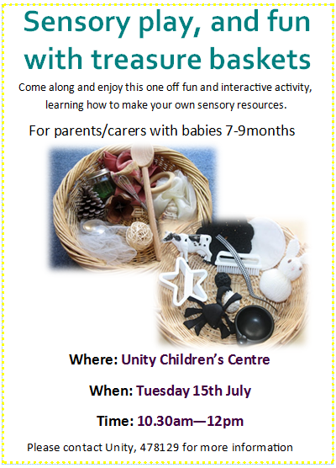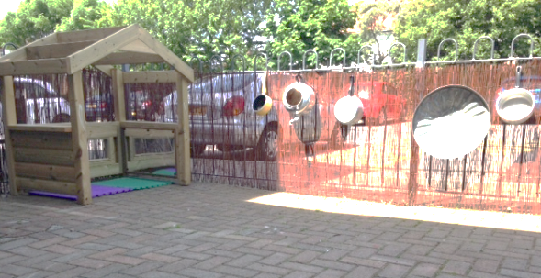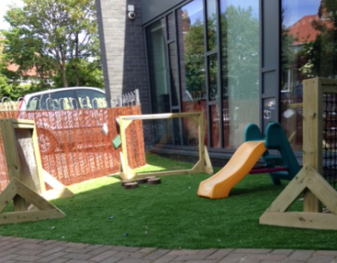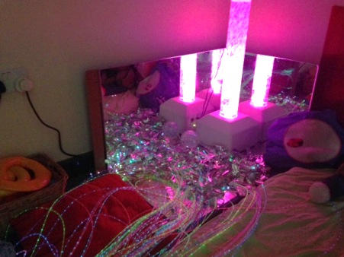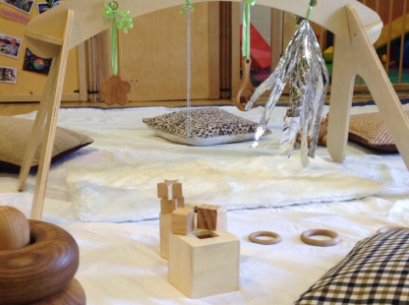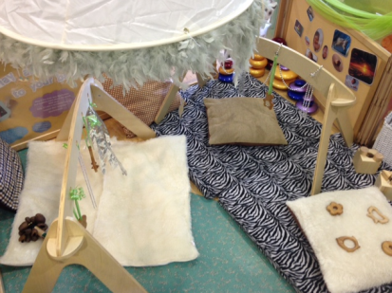

Cut out and bring with you

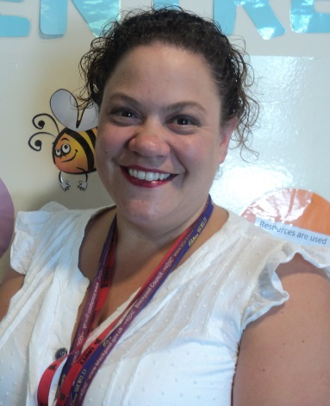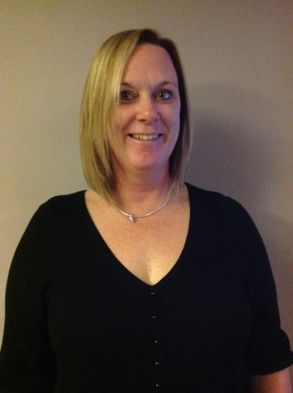

**Meet the team**

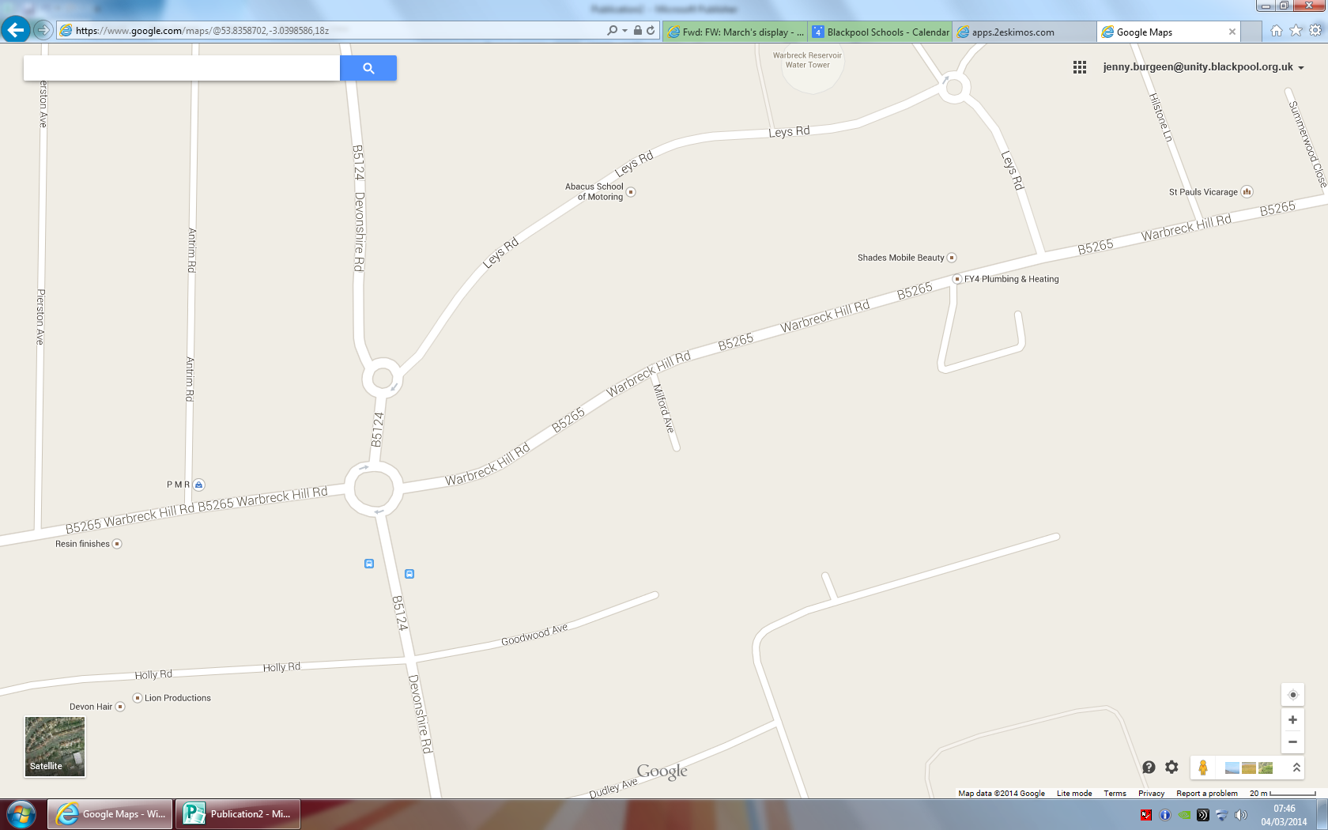

**We are open during the holidays, bring the whole family along**

**Rachael Haigh**

Children’s Centre Link Worker

**Emma Lowry**

Children’s Centre/Nursery Administrator

**Jenny Burgeen**

Children’s Centre Lead

We are located on Warbreck Hill Road. FY2 0TS

Tel 478129

We hold a drop in every Tuesday afternoon for newly registered families to come and have a look round and meet our staff.

You are also more than welcome to come at anytime to complete a registration form if not already registered with us.

We are here